How to Start Mediclinic Software from the First Sign up and set up for your use. Remember UNLIKE other companies we have call centres for you so at any time if you get stuck or want some help or explanation, WE ARE HERE. Call one of the numbers that applies to where you are from the list below in our log in screens.

When you first start a FREE TRIAL, you will be asked to enter details, so we set up a Secure Site for you.

IT IS ESSENTIAL you use a valid mobile phone number and a valid email address. These are used for verification that the site you are creating is legitimate and not spam. You will need to set up Google Authenticator 2 Factor Authentication as the ultimate in security and prevent fraudulent access to your data at any time. (Our Security is always being improved throughout your use and will be automatic causing no inconvenience.)

When starting please complete all fields. If you are Medical Practitioner (GP Or Specialist) we will automatically adjust your site so you enjoy and can use the features specific to you.

If you are a Medial professional, please make sure you tick the box
ARE YOU ONE OF THE PROVIDERS?

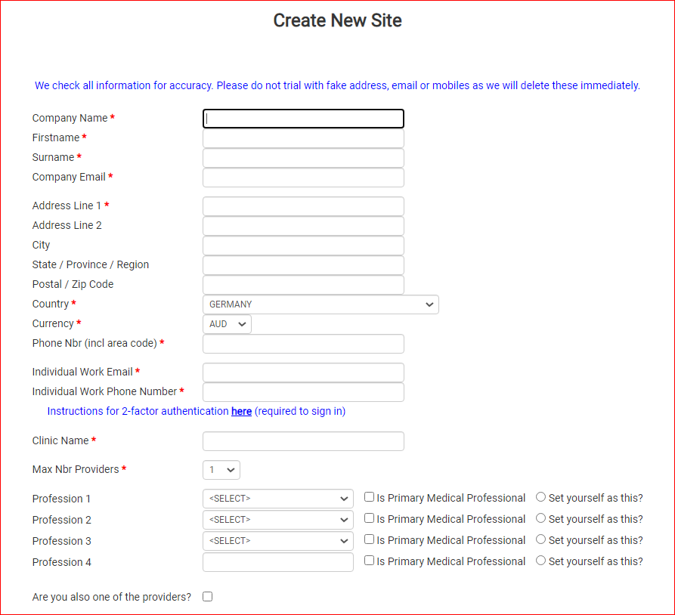

After completing this page you will be redirected to our LOG IN SITE portal.mediclinic.com.au or portal.mediclinicsoftware.eu for our European customers.

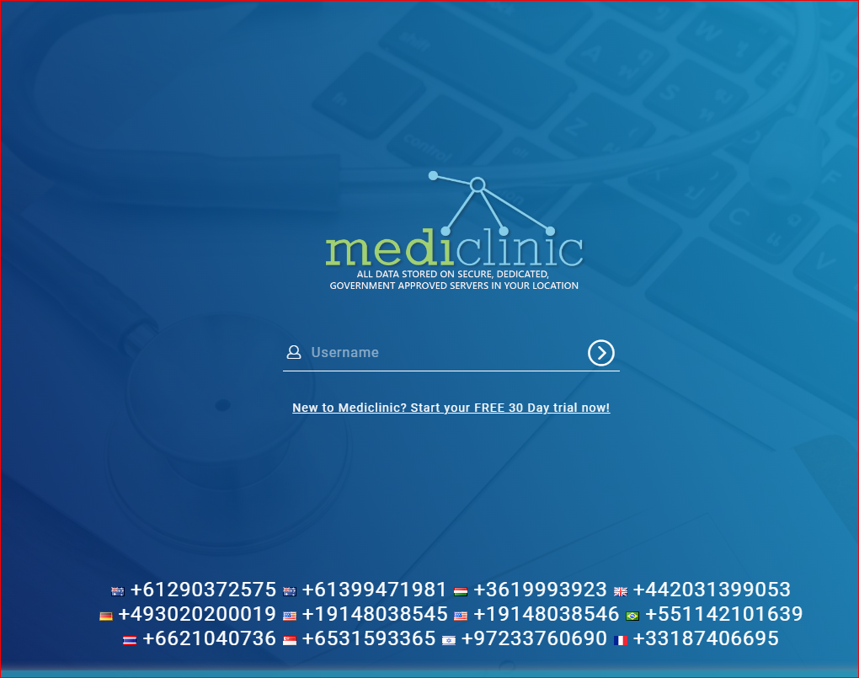

The username will be emailed to you. PLEASE SAVE this login page as a BOOKMARK in your favourites. If you forget the log in details, site, name, password at any time you can always get it from https://mediclinic.com.au/#/ or https://mediclinicsoftware.eu/en/home or https://mediclinicsoftware.de/de/home

On the next screen you will get asked to set up passwords. There is a 8 character password and a 12 character password and you MUST set using a Capital Letter and a number plus a special character. Then you will be asked to set up 2 factor authentication and we will guide you through this with easy instructions. (When setting up 2FA using your smart phone, you can use the Camera to scan the QR code.) There is an option and a tick box to REMEMBER this for 30 days. The codes saves are to THE DEVICE ONLY and the BROWSDER only so if you change web browsers or change devices or computers you will need to set up Authenticator again. We use Google Authenticator as it is the strongest available today. This simple process is one way that STOPS hackers dead in their tracks from accessing your device or details.

This is the log in page with your username
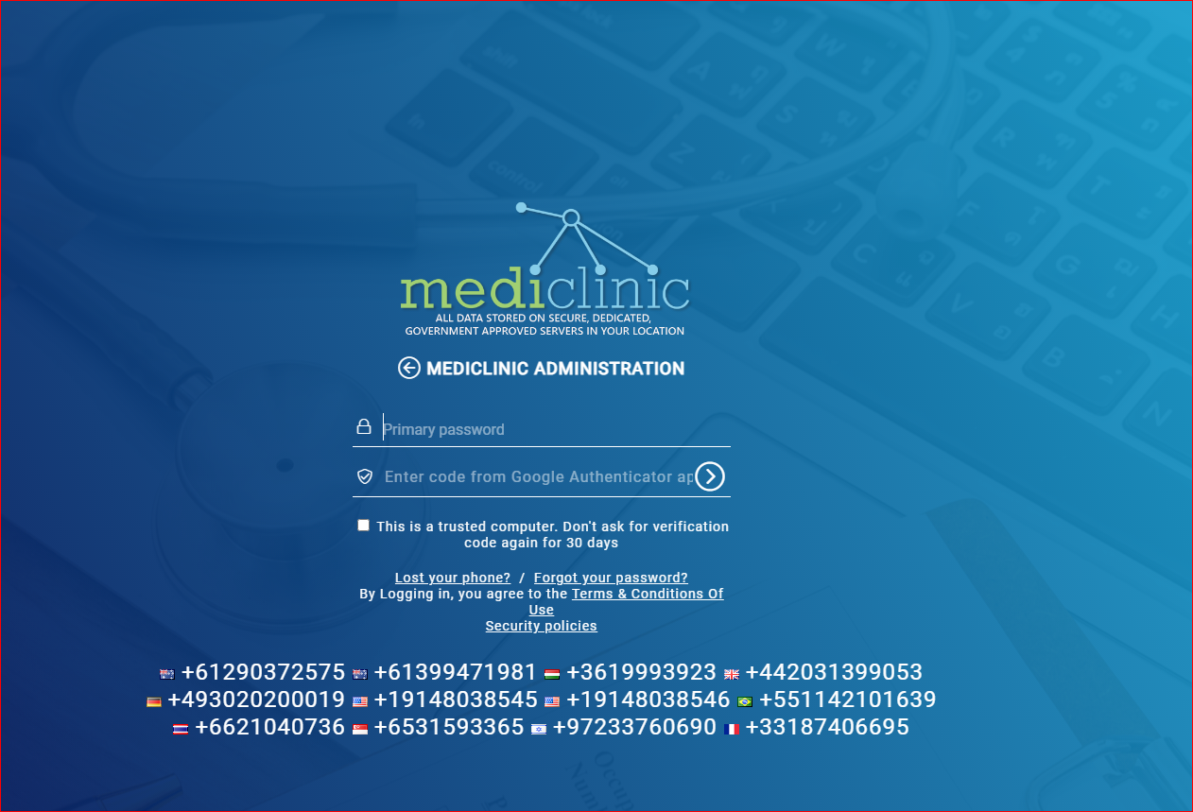

Here is where all the log in is done. THIS IS JUST A WINDOW gateway to the data bases where your data is stored, secured and encrypted. This is one of the many lines of Defense we have for bad actors who want to try to steal data. If we detect at this stage something wrong, WE SHUT OFF ACCESS and call you, the user.

Once you have signed in you will need to set up your clinic.

Mediclinic Software runs with a SITE, and multiple clinics attached to the main Site and STAFF. You can define and customise each part according to your needs.

FIRT and after signing in go to CLINICS in the main menu on the left hand side. Click on CLINICS sub menu and click on the CLINIC we made for you when setting up your site.

You will see many areas which YOU need to decide what you want Staff to see and what you want in YOUR CLINIC, and REMEMBER SITE is First and overrides all others as it is the BOSS. Then comes CLINC and this is Specific to all staff and functions of this CLINIC and this is shown on Google searches and ONLINE bookings. Please read carefully all the details and WE ARE HERE to help and assist at every stage SO ASK US - email or CALL.

One important thing to remember is that you must ALLOCATE Staff to a Clinic or that STAFF – EVEN ADMIN – cannot see anything that relates to that clinic. If you have many clinic locations, you must add the STAFF to each clinic. USE THE EDIT STAFF function.

On the screens here you will also see a CHAT icon and you can CHAT internally to any logged on Staff at any time SECURELY Encrypted and private.

Form here on we recommend you look at our website which is constantly updated as we get time for more HELP and also on the GREEN Menu item called HELP in the login site page.

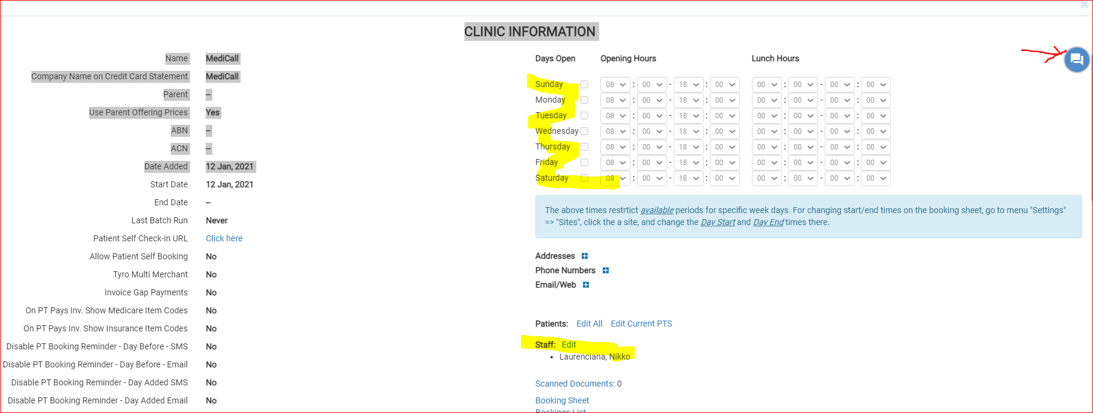

We also have TELEHEALTH / CHAT and SECURE MAIL SITES where you do not need pay for use and these are covered separately.

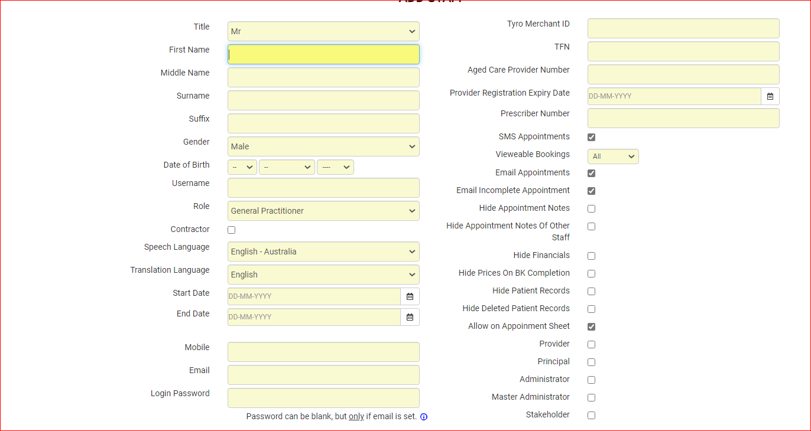

If you are using The Patient Medical System PMS site of portal.mediclinic then SECURE mail and TELEHEALTH are included FREE OF CHARGE.

For more help and videos go to here.
https://www.mediclinic.com.au/#/help/getstarted

